AIM: Learning basics of Python

Program 1:Write a program to demonstrate the following operators in Python
i-Arithmatic Operator ii- Logical Operator iii- Bitwise Operator
Solution 1:
print("\nArithmatic Operators\n")
a=2
b=3
print("a=",a)
print("b=",b)
print('Addition: a+b=',a+b)
print("Subtraction: a-b",a-b)
print("Multiplication: a*b",a*b)
print("Floor Divison: a//b",a//b)
print("Divison: a/b",a/b)
print("Exponent:a**b",a**b)
print("Modulous:a%b",a%b)
print("\nLogical Operators\n")
x = True
y = False
print("x=True")
print("y=False")
print('x and y is',x and y)
print('x or y is',x or y)
print('not x is',not x)
print("\nBitwise Operators\n")
a=2
b=3
print("a=",a)
print("b=",b)
print("AND Operator: a&b= ", a & b)
print("OR Operator:a|b=", a | b)
print("EXCLUSIVE OR Operator:a^b", a ^ b)
print("NOT Operator:~a", ~a)
print("LEFT SHIFT Operator:a<<b=", a << 1)
print("RIGHT SHIFT Operator:a>>b=", b >> 1)

Output 1:
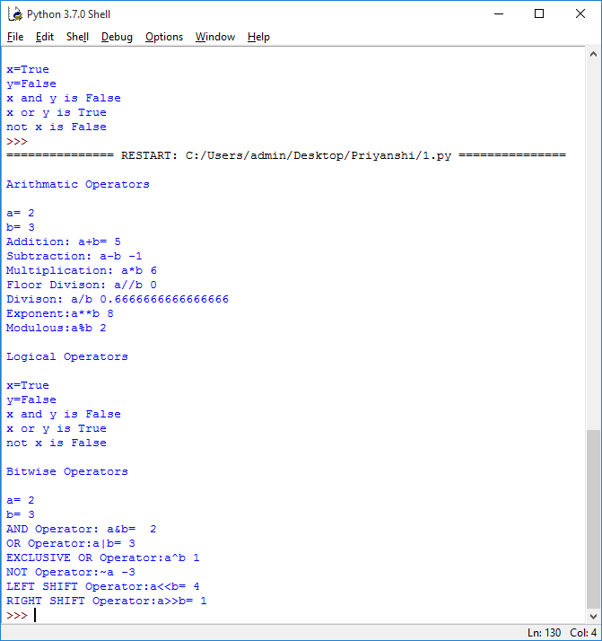

Program 2: Write a program to demonstrate the use of membership in Python
Solution 2:
list=[1,3,5,7]
a=5
fori in range(0,len(list)*2):
ifi in list:
print(i," in list")
ifi not in list:
print(i," not in list")
if(type(a) is int):
print("a=5,type(a) is int:True")
if(type(a) is not float):
print("a=5,type(a) is not float:True")
Output 2:

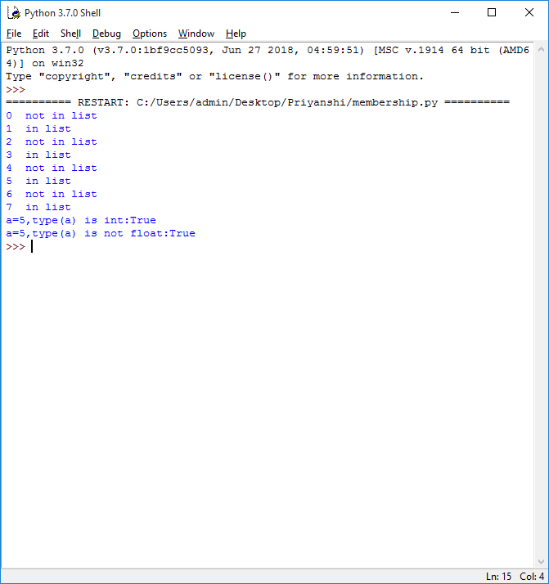

Program 3: Write a program to demonstrate various types of Data Structures in Python
Solution 3:
print("Data Structure:Array\n")
import array as ar
a=ar.array('i',[1,2,3])
print("Array is:")
fori in range(0,len(a)):
print(a[i],end=" ")
print("\nAppend Function: a.append(10)")
a.append(10)
fori in range(0,len(a)):
print(a[i],end=" ")
print("\nInsert Function: a.insert(2,30))")
a.insert(2,30)
fori in range(0,len(a)):
print(a[i],end=" ")
print("\n\nDataStructure:List\n")
list1= ["Priyanshi","Tanya","Surbhi","Banka","Maitri"]
print("List is:",list1)
print("Accessing a particular item from list as list1[0]:",list1[0])
list1[4] = 160355
print("Changing item value in the list aslist1[4]=160355: ",list1)
print("Length of list is checked as len(list1):",len(list1))
list1.remove(160355)
print("Removing from a list as list1.remove(160355):",list1)
list1.pop()
print("Popping from a list as list1.pop():",list1)
del list1[2]
print("Deleting from a list as del list1[2]:",list1)
print("\nDataStructure:Tuple\n")
l = (1, 2, 3, 4, 5)
print("Tuppleis:",l)
print("Accessing a particular item from tuple as l[0]:",l[0])
print("Negative indexes in tuple as l[-2]:",l[-1])
print("Slicing Operator as l[0:2]",l[0:2])
print("Comparison in tuple when a=(5,6) b=(1,4)")
a=(5,6)
b=(1,4)
if (a>b):
print("a is bigger")
else:
print("b is bigger")
print("\nDataStructure:Dictionary\n")
d = {}
print("Adding key - value pairs to dictionary as d['priya']=160355 d['abc'] = 345 ")
d['priya']=160355
d['abc'] = 345
print("Printing the whole dictionary as d", d)
print("print only the keys as d.keys()",d.keys())
print("Print only values as d.values()",d.values())
print("Check if key exist as 'xyz' in d ",'xyz' in d)
del d['abc']
print("Deleting the key-value pair as del d['abc'] ",d)
print(d)
print("\nDataStructure:Sets\n")
set = set()
print("Adding elements to a set using for loop")
fori in range(1, 6):
set.add(i)
print("Set = ", set)
Output 3:
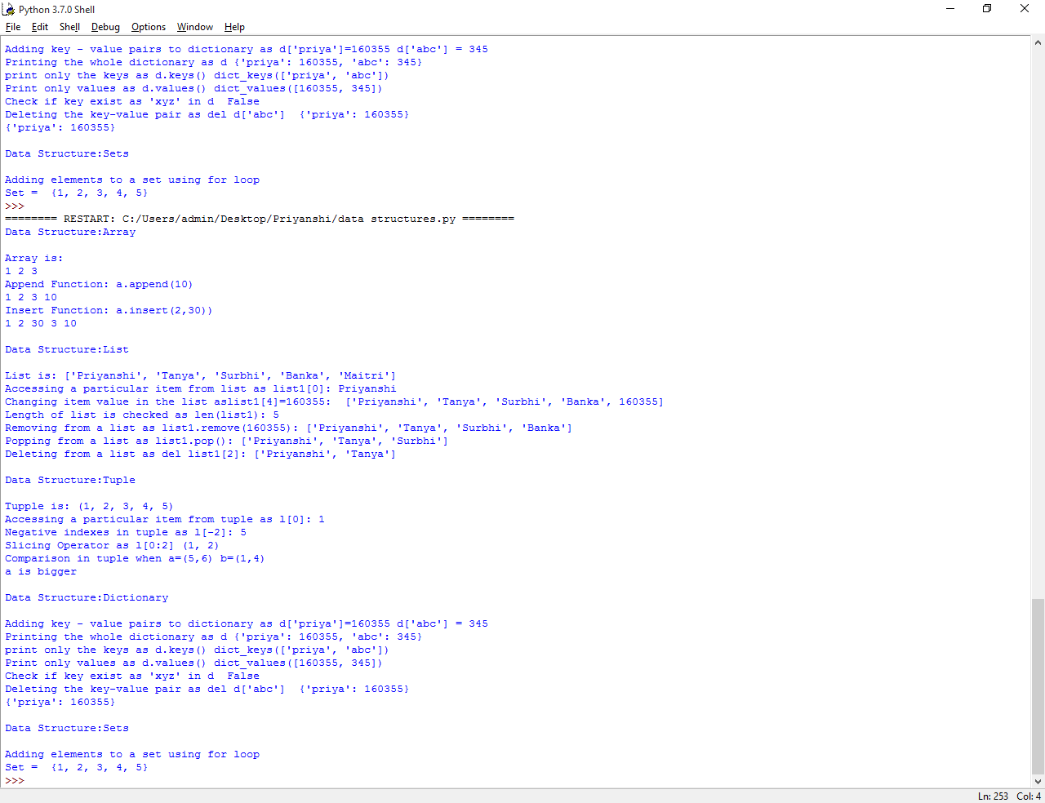
Program 4: Write a program to demonstrate the use of user-defined functions in Python
Solution 4:
def add(a,b):
returna+b
print(add(5,6))
